AWS Portal: <https://aws.amazon.com/console/>

**Overview of Amazon Web Services**

## Abstract

The AWS Cloud provides a broad set of infrastructure services, such as computing power, storage options, networking and databases that are delivered as a utility: on-demand, available in seconds, with pay-as-you-go pricing. From data warehousing to deployment tools, directories to content delivery, over 90 AWS services are available. New services can be provisioned quickly, without upfront capital expense. This allows enterprises, start-ups, small and medium-sized businesses, and customers in the public sector to access the building blocks they need to respond quickly to changing business requirements. This whitepaper provides you with an overview of the benefits of the AWS Cloud and introduces you to the services that make up the platform.

AWS Services :

* Amazon Elastic Compute Cloud. ...
* Amazon Simple Storage Service. ...
* Amazon Elastic MapReduce. ...
* Amazon CloudFront. ...
* Amazon SimpleDB. ...
* Amazon Relational Database Service. ...
* Amazon Simple Queue Service. ...
* Amazon Simple Notification Service.

Etc.

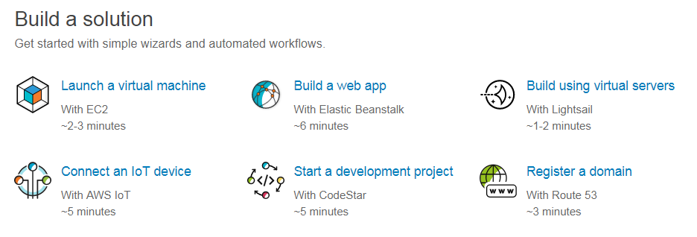

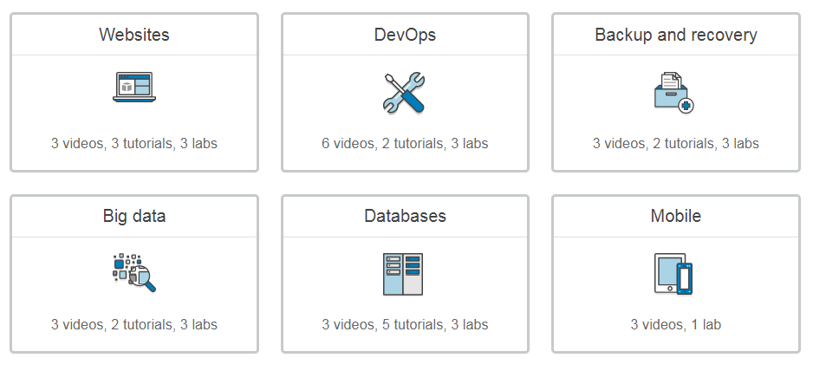

<https://aws.amazon.com/getting-started/tutorials/>

